Ex.no:9 | MINI PROJECT – HEALTHCARE ANALYTICS
Date: | MINI PROJECT – HEALTHCARE ANALYTICS

Domain and Problem Statement
Domain: Healthcare Data Analytics & Hospital Performance Analysis

Problem Statement:
Healthcare organizations generate large volumes of hospital-related data but often lack clear insights into hospital distribution, ratings, reviews, and regional patterns. This project addresses these challenges by transforming hospital data into structured business intelligence using Power BI and Tableau, enabling analysis of hospital distribution across states and cities, average ratings, review patterns, and overall hospital performance to support data-driven healthcare analysis.

Dataset Description
Dataset Name: Hospital Analytics Dataset Granularity: Each row represents a single hospital.
Key Entities & Attributes:
- Hospital & Location: id, City, State, District
- Geographical Information: Density, Latitude, Longitude
- Hospital Performance: Rating, Number of Reviews

Data Source:

Primary Source: Hospital Analytics Dataset prepared for healthcare and hospital performance analysis.

Storage Infrastructure:
Cleaned and pre-processed hospital records maintained in a CSV dataset and imported into Microsoft SQL Server, Power BI and Tableau for interactive dashboard development and analysis.

Architecture:

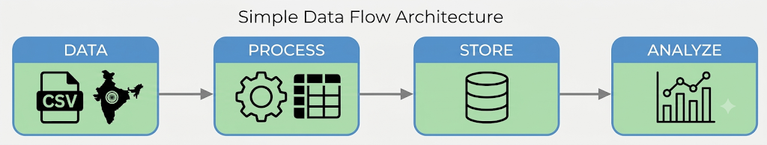

Program:
- Python – Data Cleaning & Transformation
import pandas as pd
df = pd.read_csv("Hospitals In India (Anonymized).csv") hospitals = df.copy()

hospitals["City"] = hospitals["City"].fillna("Unknown") hospitals["State"] = hospitals["State"].fillna("Unknown") hospitals["District"] = hospitals["District"].fillna("Unknown") numeric_columns = [
"Density", "Latitude", "Longitude", "Rating",
"Number of Reviews"
]
for column in numeric_columns: hospitals[column] = hospitals[column].fillna(0)
hospitals.drop_duplicates(inplace=True) hospitals.columns = (
hospitals.columns
.str.lower()
.str.strip()
.str.replace(" ", "_")) print("Original Shape:", df.shape)
print("Cleaned Shape:", hospitals.shape) print("\nDataset Preview:") print(hospitals.head())
print("\nDataset Information:") print(hospitals.info())
- SQL SERVER CONNECTIVITY

INSTALL SQL SERVER MANAGEMENT STUDIO
- Create database named “miniproject2”
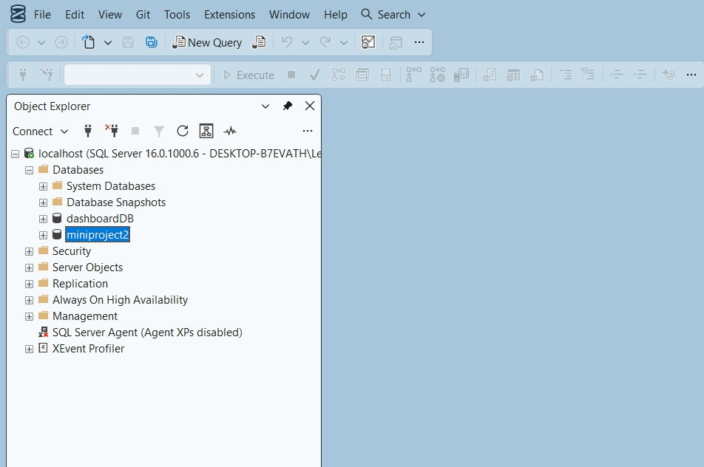
- Import the csv file of the dataset
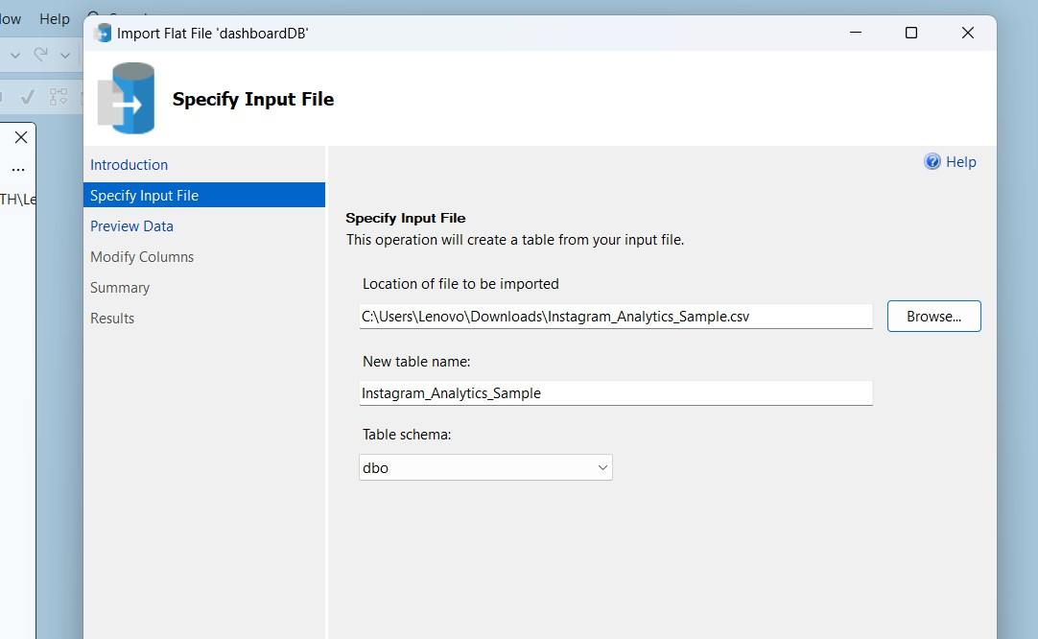
POWER BI
- Now go to MICROSOFT POWER BI
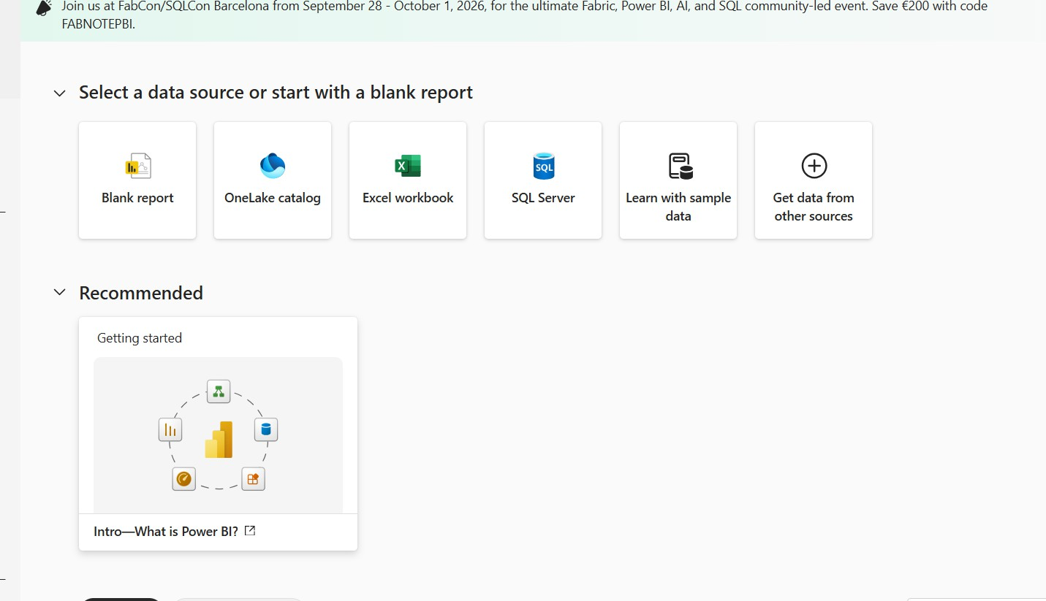

- Click SQL SERVER
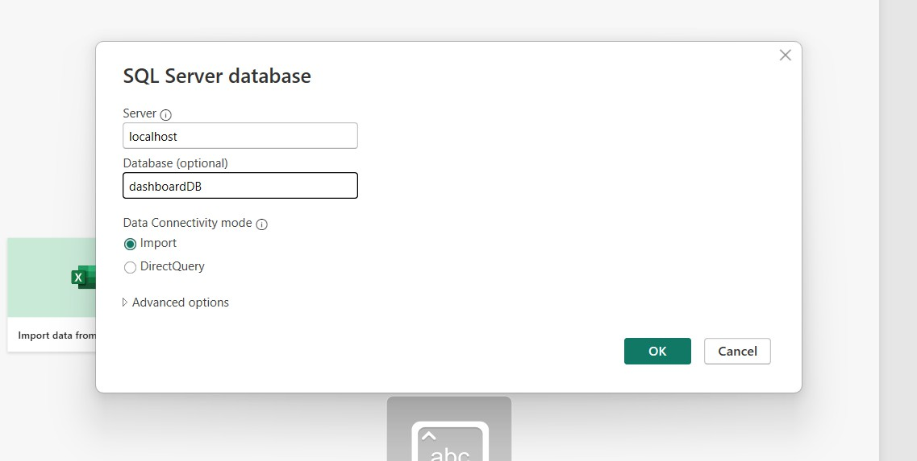
- Click OK and click transform data
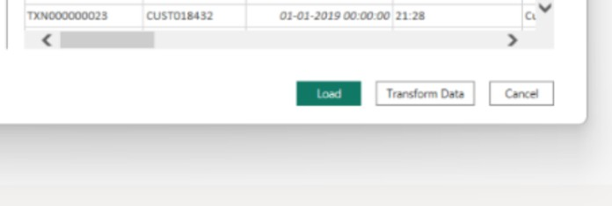

- Create DAX measures TOTAL HOSPITALS :
AVERAGE RATING :
- Power BI Final Executive Dashboard & Drill-Through
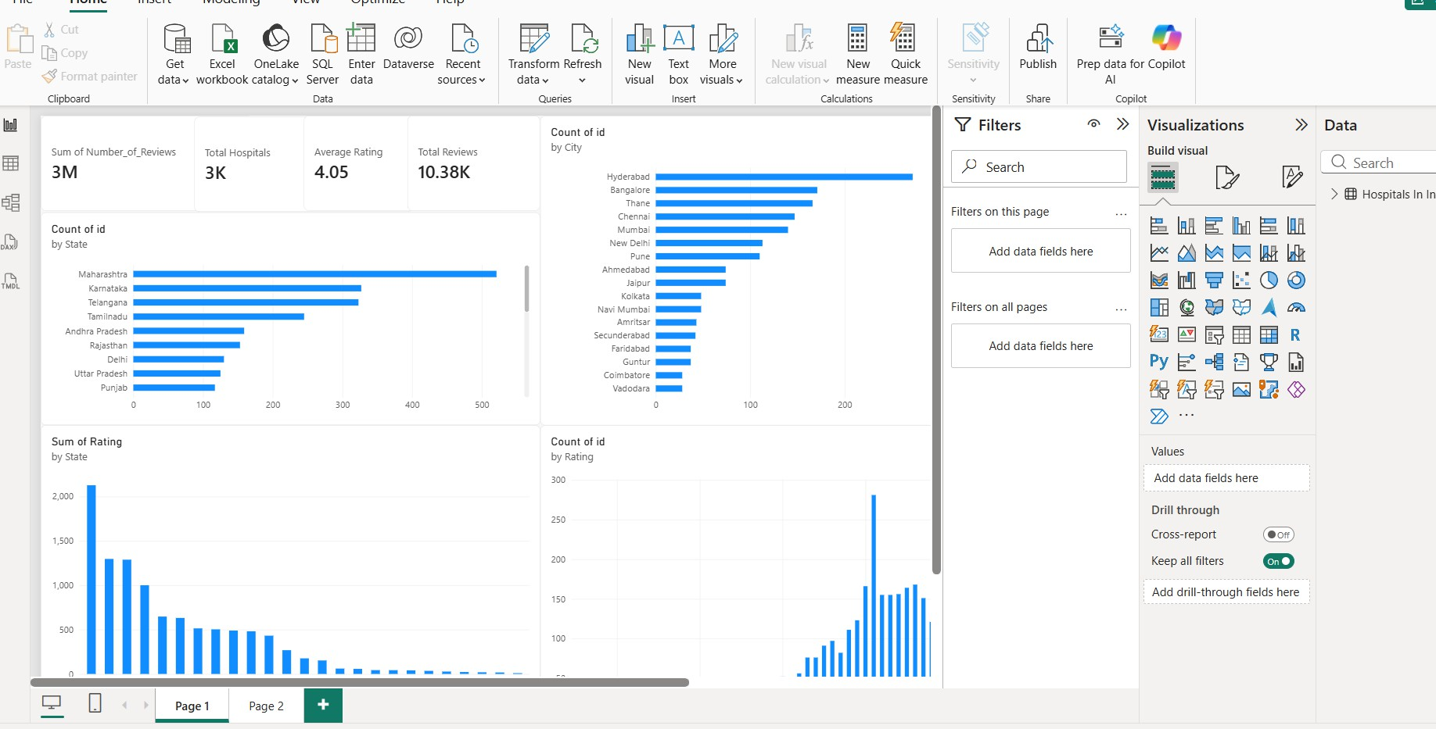
1. Executive Canvas:
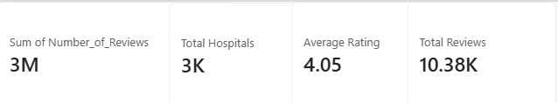
Place Card Visuals across the top:
Visualise number of hospitals in each state
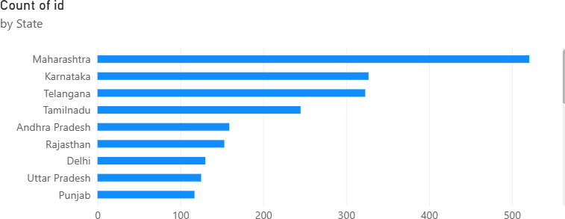

count number of hospitals by city
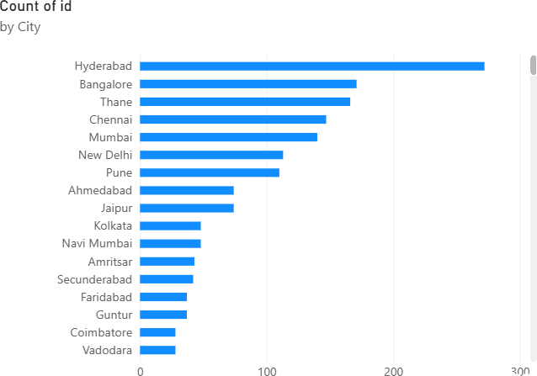
Count of id by rating
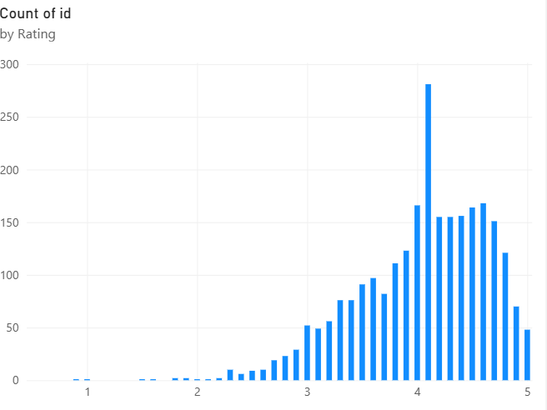
Total rating by states
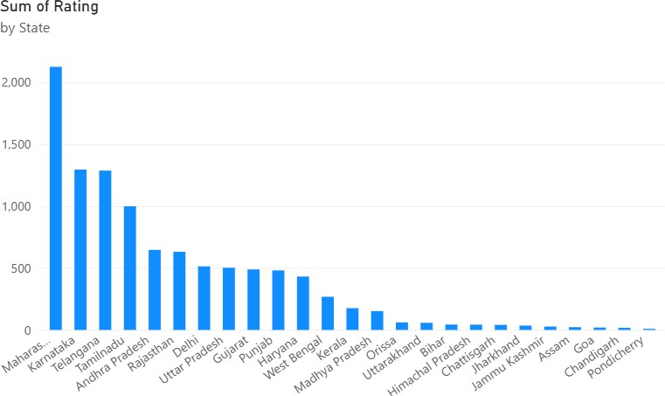

Create 2 slicers by state and city
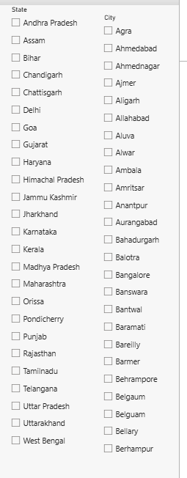

Implement drill through
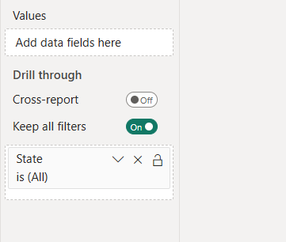

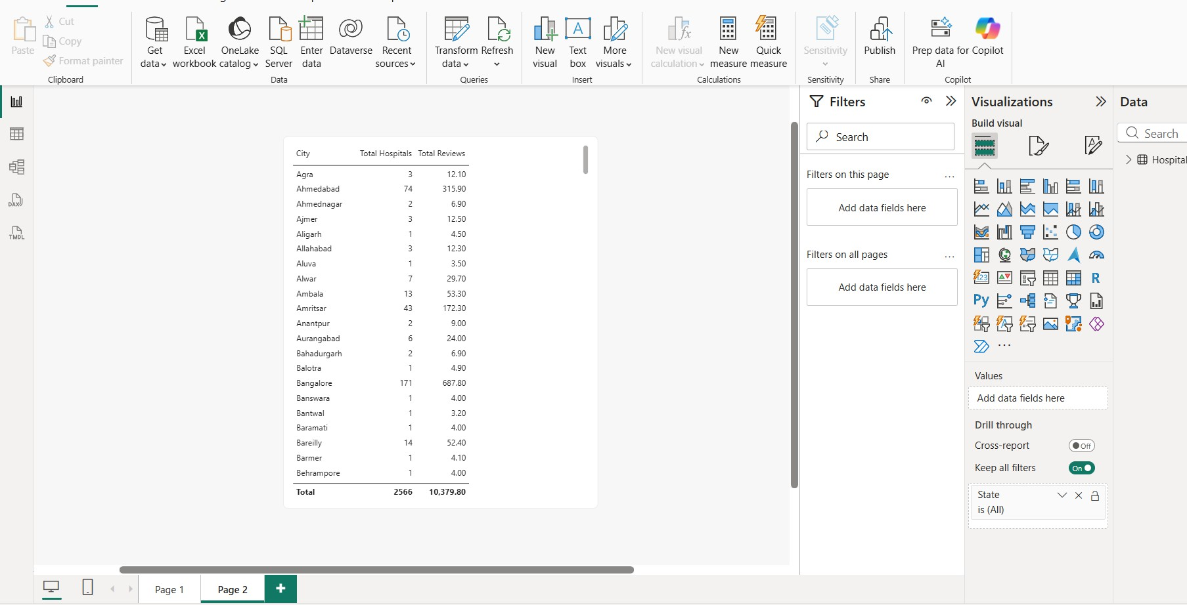

TABLEAU
Import the data from sql server
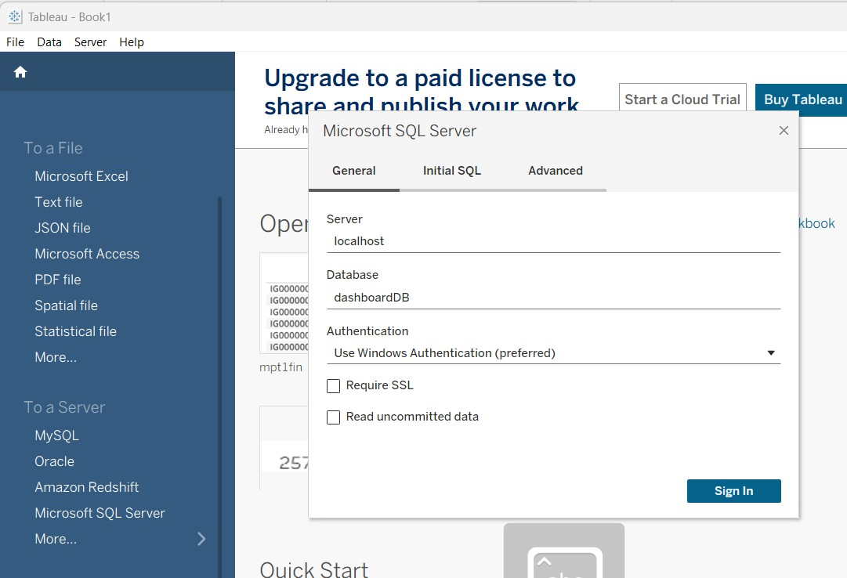

FINAL DASHBOARD :
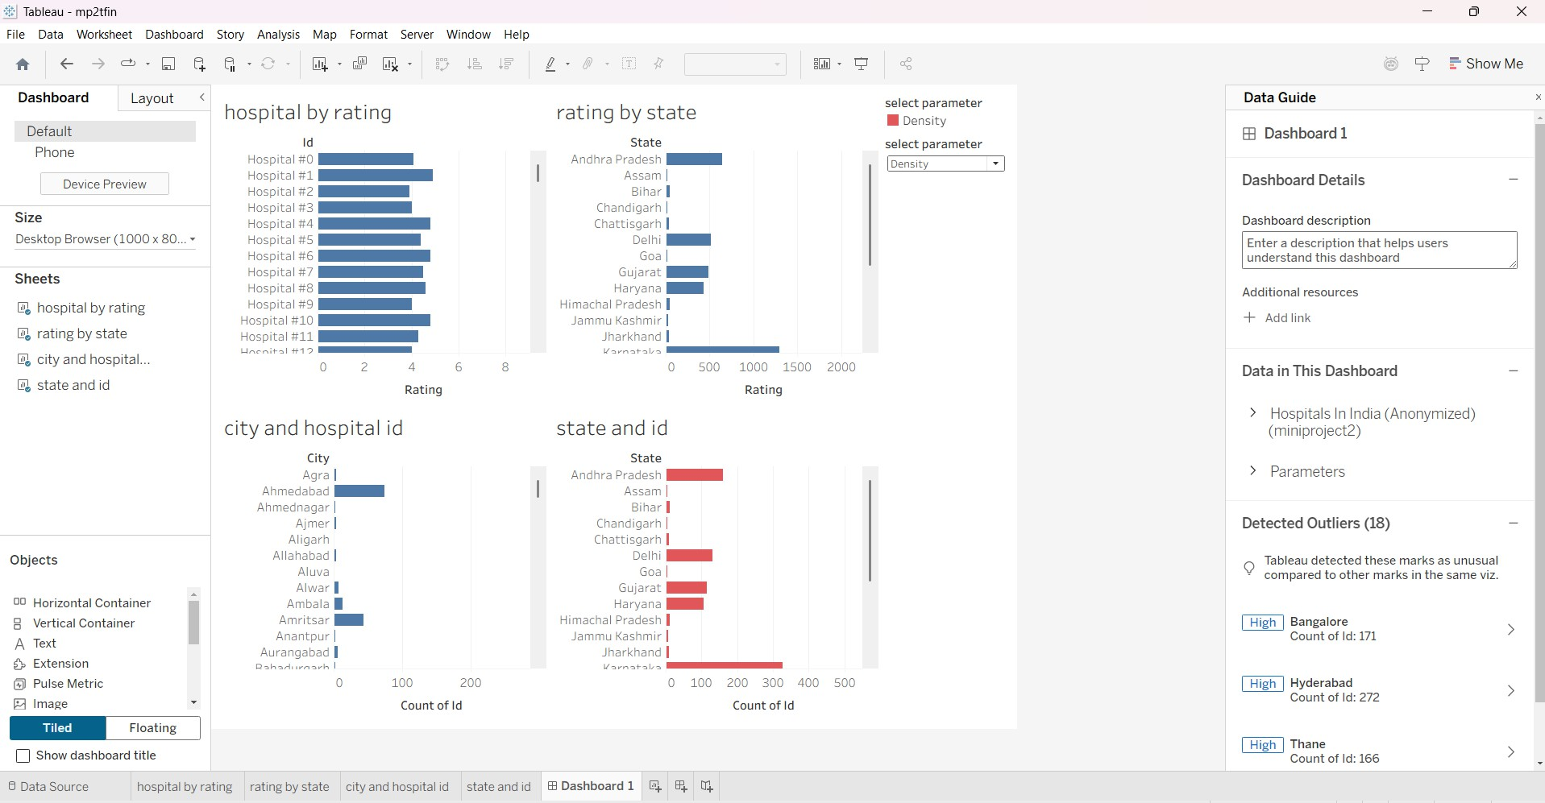

Build parameters
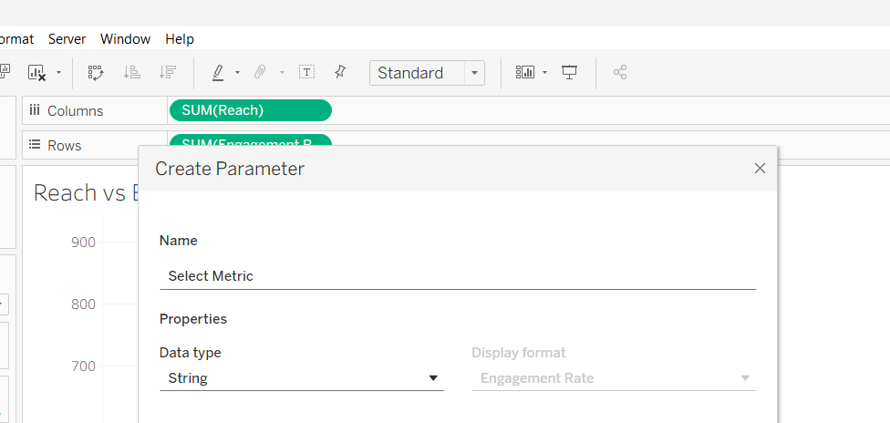

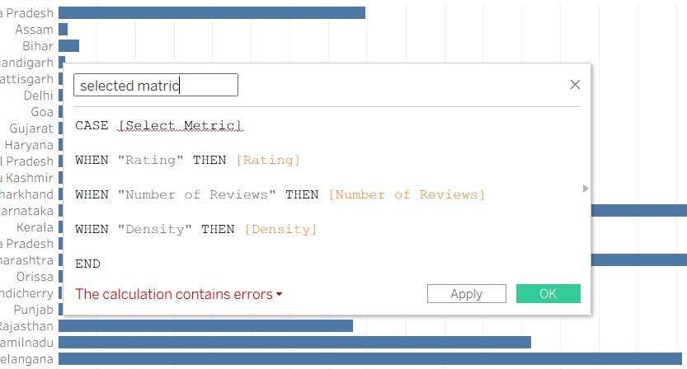

To visualise hospital by rating
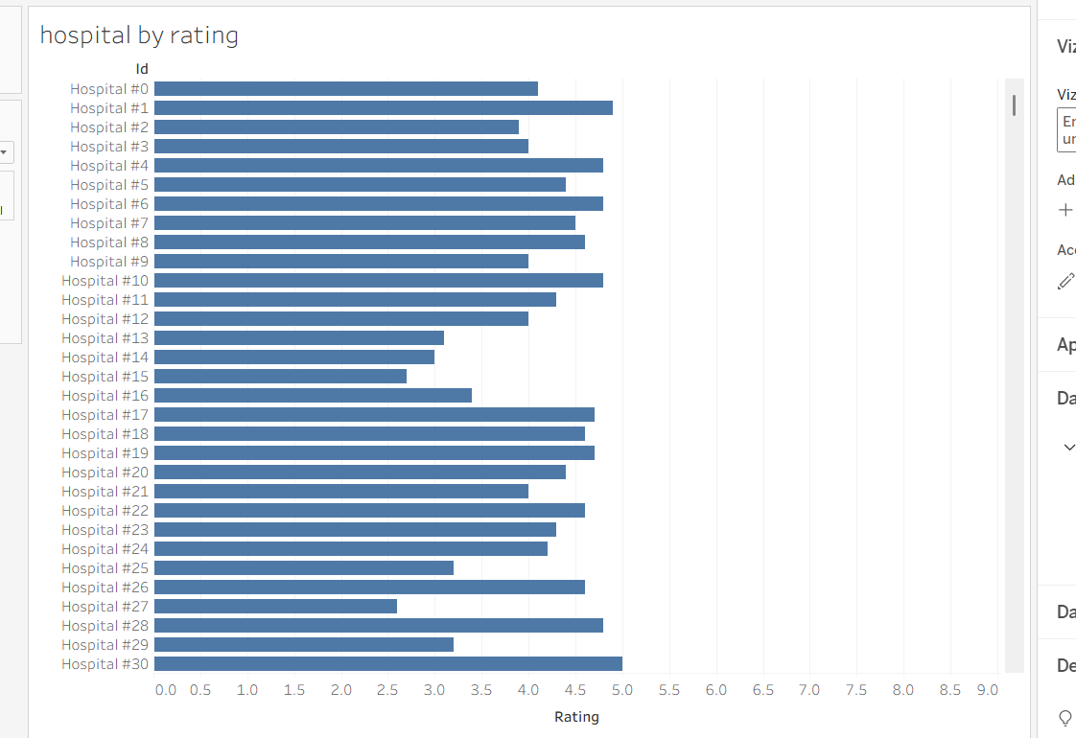

To visualize rating by state
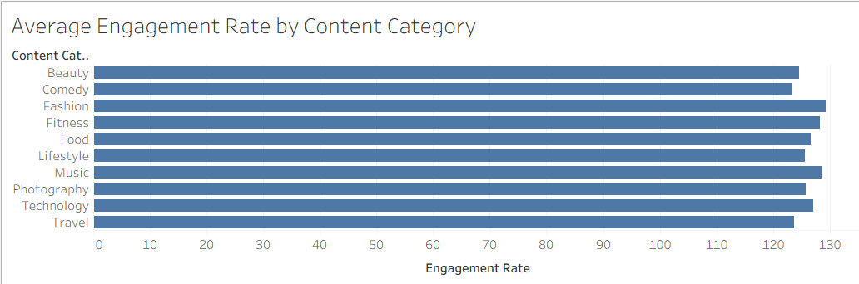

To visualize number of hospitals in each city
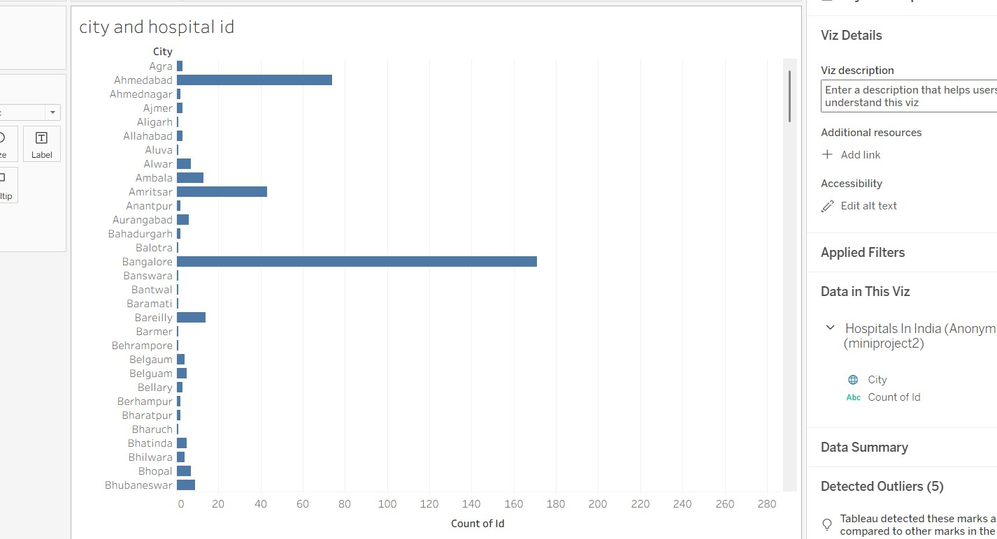

To visualise number of hospitals in each state
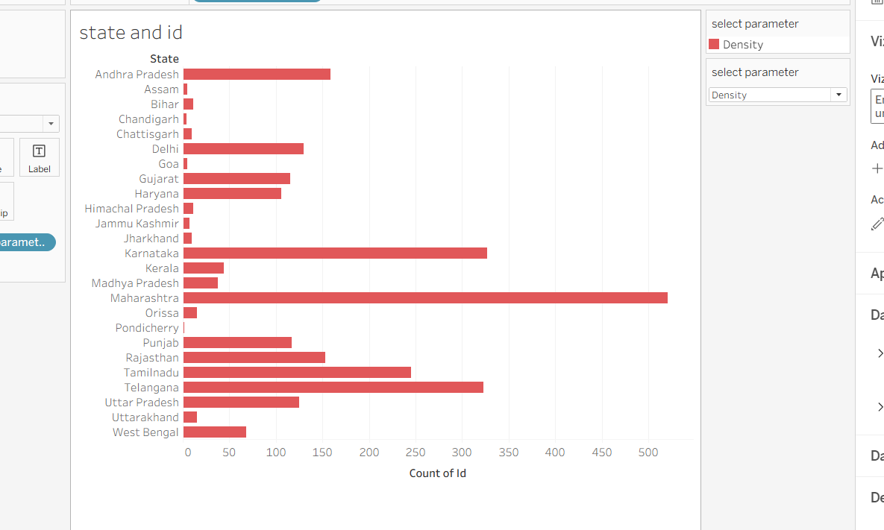

Observed Insights

• Hospital Ratings: Overall ratings are good (mostly between 3 and 5). Hospital#1 leads the group with a near-perfect score, while ratings across all listed hospitals remain steady and consistent.
• Ratings by State: Karnataka leads in overall rating values, with Andhra Pradesh close behind. Delhi, Gujarat, and Haryana also score well, whereas states like Bihar, Assam, and Chandigarh lag far behind.
• Hospitals by City: Ahmedabad has the highest number of hospitals, followed by Amritsar. Cities like Agra, Ajmer, Aligarh, and Allahabad have the fewest.
• Hospitals by State: Karnataka has the most hospitals overall, followed closely by Andhra Pradesh and Delhi. Assam, Bihar, Chandigarh, and Chhattisgarh have the lowest numbers

